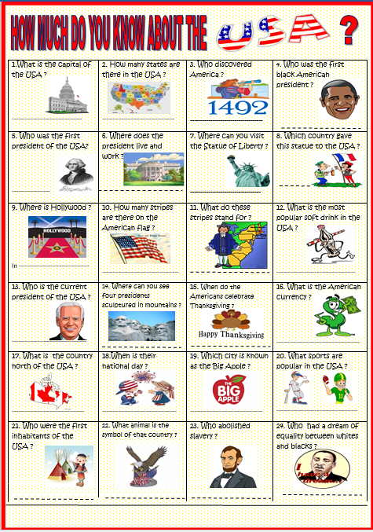

If you are connected, here are two more activities to do :

<https://learningapps.org/watch?v=pj2k66f3t21>

<https://learningapps.org/watch?v=pw3oyad1521>