**OBJECTIFS: REDECOUVRIR LA FETE DE LA ST PATRICK ET REVOIR LE PRESENT SIMPLE POUR EXPRIMER UNE HABITUDE.**

1. **Christine parle de la St Patrick. Ecoute-la 3 fois et prends des notes. Puis essaie de compléter la grille ci-dessous.**

St Patrick’s Day is a **special day** in Ireland that takes place every year on the **17th of March**. It is a public holiday in Ireland and is also celebrated by people in **Great Britain, America, Australia, Canada, New Zealand, Argentina** and more countries. It is named after the St Patrick, the most popular saint of Ireland. He was born in the **4th century** and died on the **17th of March 461**. The holiday became an official holiday in Ireland in **1903**. It is now a **5-day celebration** when many people **wear the colour green**, **have parades, festivals, concerts, fireworks, performances and drink a lot of beer**.

**What do people do on St Patrick’s Day? Listen and circle the good answers or complete.**

St Patrick’s Day is a *strange day normal day special day* in Ireland.

It takes place every year on *March 7th March 17th April 17th*

It is also celebrated in ………………………. ……………………………….., ………..……......................., ……..................................., ……………………………..…….., ……..………… …………..…………………….., ……………………………..…….. and more countries.

St Patrick was born in the *2nd century 3rd century 4th century 5th century.*

He died on *March 7th, 461 March 17th, 641 March 17th, 461*

St Patrick became an official holiday in *903 1903 1913 1933.*

It is a *2-day 3-day 4-day 5-day* celebration.

On St Patrick’s day, people .................................................................................................................................................................

…………………………………………………………………………………………………………………………

1. **Relie les dates aux fêtes puis fais des phrases à l’oral ET à l’écrit en suivant l’exemple.**

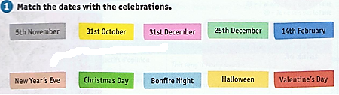

**Ex: Valentine’s Day is on the fourteenth of February.**

1. **Relie la colonne A (verbes) à la colonne B (noms) puis complète les phrases.**

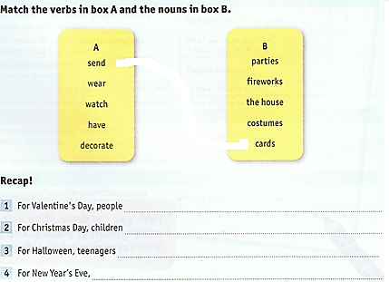



Ces phrases sont au **présent simple** car elles expriment une **habitude**, quelque chose que les gens font **tous les ans**.

1. **Relie le cours dans ton livre à la page 32 (3 le présent simple) et fais l’exercice 3 page 33.**
2. 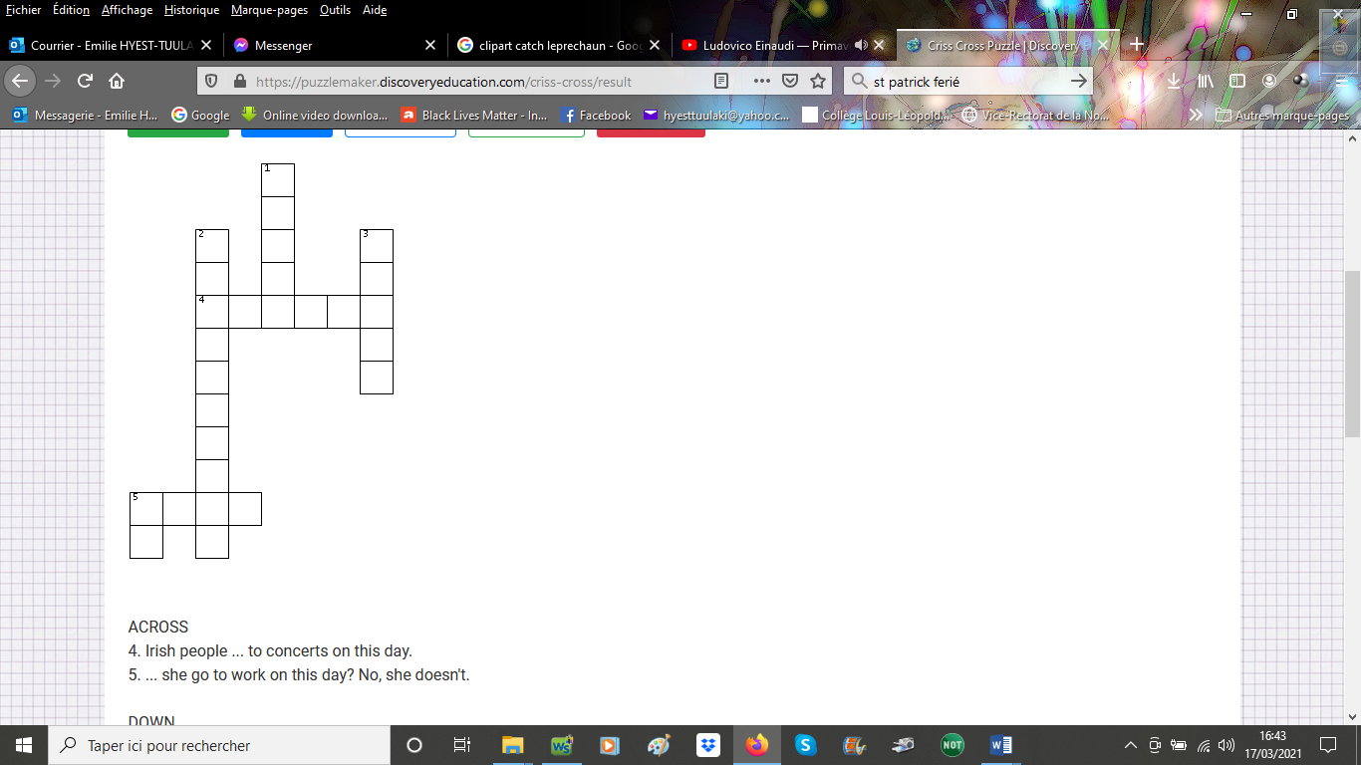**Fais les mots croisés avec des verbes ou auxiliaires au présent simple.**

