Discover….
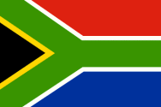 | - Which country does this flag belong to?  ………………………………………………………………………………  - What is the nickname of this country ?  ………………………………………………………………………………  - What are the 3 capital cities ?  ………………………………………………………………………………  - What is the largest city ?  ………………………………………………………………………………  - How many inhabitants are there ?  ………………………………………………………………………………

- Who is the man on the photo ?  …………………………………………………………………………………………  - Which political system did he fight against ?  …………………………………………………………………………………………  - How many years did he spend in prison ?  …………………………………………………………………………………………  - On which island was he imprisoned ?  …………………………………………………………………………………………  - What was his occupation from 1994 to 1999?  …………………………………………………………………………………………  - When did he receive the Nobel Peace Prize ?  …………………………………………………………………………………………  - When did he die ?  ………………………………………………………………………………………… | 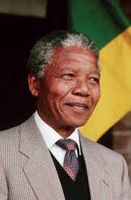

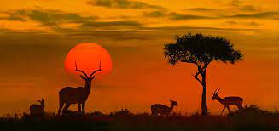 | - What is the most famous National Park there ?  ………………………………………………………………………………  - What are the Big Five in this National Park ?  ……………………………………………………………………………….  - Look at these signboards and write 4 rules applied there :  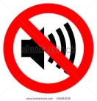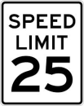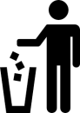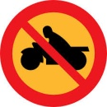  ………………………………………………………………………………  ……………………………………………………………………………….  ……………………………………………………………………………….  ……………………………………………………………………………….

- Which sport is very popular in this country ?  ………………………………………………………………………….  - What is the name of the national team ?  ……………………………………………………………………………  - When did they win the World Cup ?  …………………………………………………………………………… | 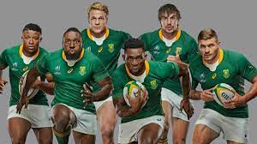
Voici deux activités en plus si tu as internet: https://learningapps.org/watch?v=pdd0tn8xk21
https://learningapps.org/watch?v=ptaw9sy3t21

