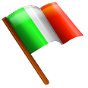
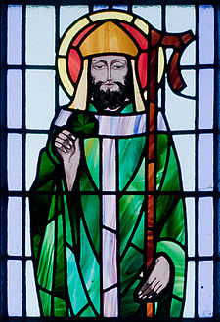
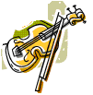
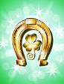
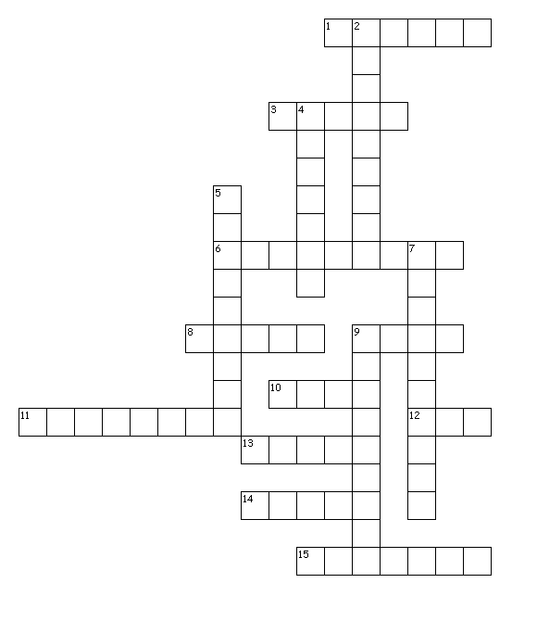
Write the answers in the Crossword and the numbers in the boxes.

Across
1 a musical instrument with strings
3 a Christian symbol
6 a container filled with coins
8 the colour people wear on 17th March in Ireland
9 a large musical instrument with strings stretched on a vertical frame
10 an alcoholic drink
11 the national emblem of Ireland
12 a cap
13 an animal with a long body and no legs
14 the third month of the year
15 a country in Western Europe
Down
1 a piece of cloth with a special pattern, a symbol of Ireland
2 a half circle of bright colours that you see in the sky when rain and sun come together
5 the patron saint of Ireland
7 a small man with magic powers in Irish stories
9 a piece of curved iron that is attached with nails to the bottom of a horse’s foot

