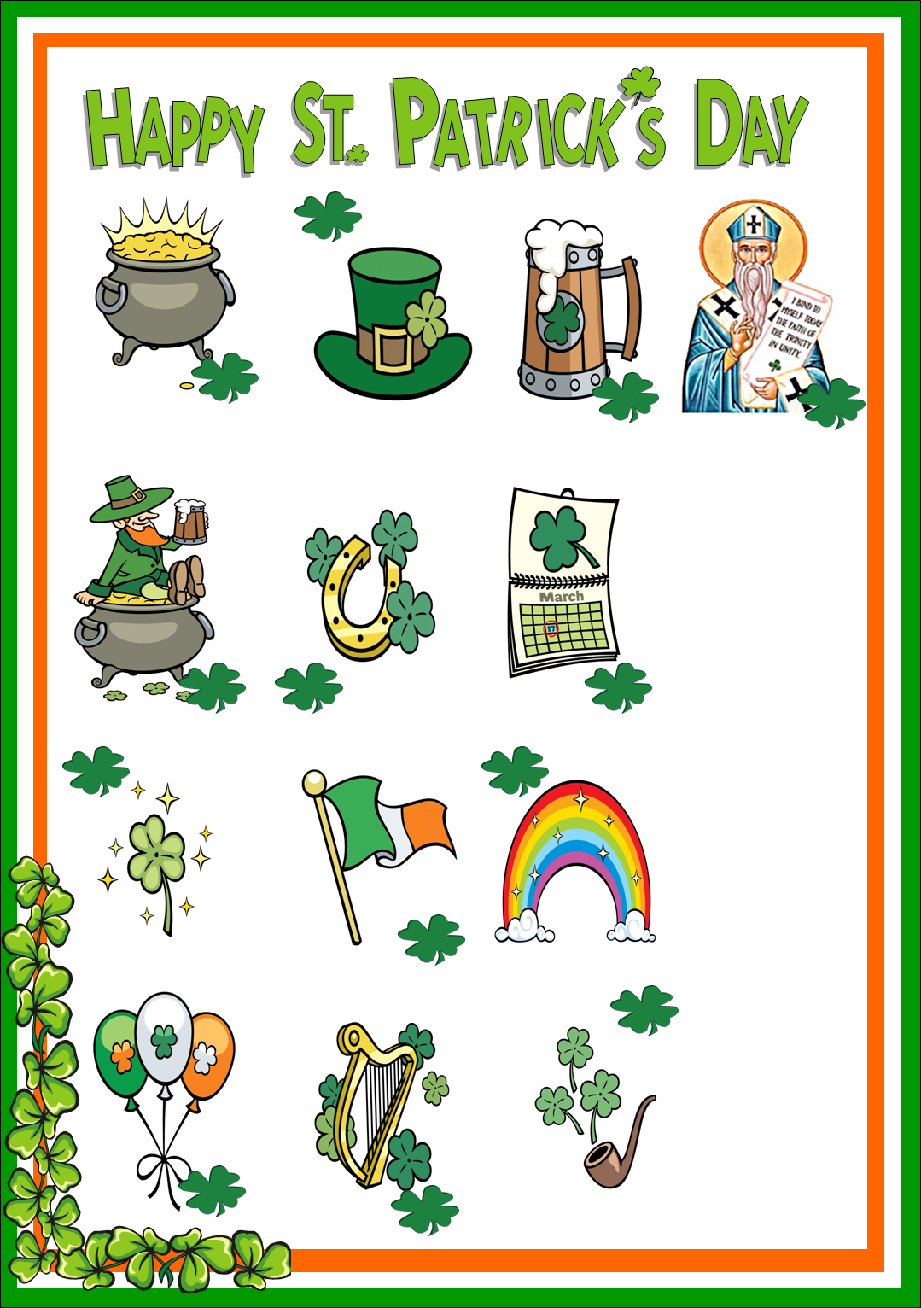
PIPE
HAT
BEER
SAINT PATRICK
HARP
BALLOONS
RAINBOW
IRISH FLAG
SHAMROCK
ST. PATRICK´S DAY
HORSESHOE
LEPRECHAUN
POT OF GOLD

