Suite du travail sur la Mission 2; Describing someone

Read the text.
Hello! My name is Linda Minogue. I’m Australian. I have got two sisters and five brothers. I live with my parents in Sidney, a beautiful city near the coast.
Our family is quite big. I have got three grandparents. On my father’s side I have only got one grandmother. She lives in my house. She is very old. She is eighty-five years old. Her birthday is on 11th July. She has got short wavy white hair.
I have got four uncles, seven aunts and twenty-five cousins. I love our birthdays and Christmas. We make great parties for all the family.
Today I am in Portugal on holiday. I am here with my husband and my two daughters. We love Portugal.


1. According to the text mark the sentences as True ( T ) or False ( F ).
( T ) ( F )
- Her name is Tracy
- She lives in Portugal.
- She has got 35 cousins.
- She is from Australia.
- Today she is in Portugal with her father.
2. Now complete the sentences using information from the text.
a. Linda has got _____________________sisters and five ________________________.
b. She lives in __________________________, a city ______________________________.
c. Her grandmother ____________________________ years old.
d. Linda _________________________ two daughters.
3. Answer the questions according to the text.
- Where is Linda from? _____________________________________________________________.
- What nationality is she? ___________________________________________________________.
- Is Linda’s family small? ____________________________________________________________.
- How old is her grandmother? _______________________________________________________.
- When is her birthday? ____________________________________________________________.
- What’s her grandmother’s hair like?__________________________________________________.
- How many cousins has Linda got? ___________________________________________________.
4. Ask questions for the following answers.
- __________________________________________? Her surname is Minogue.
- __________________________________________? No, she isn’t. She is Australian.
- __________________________________________? She has got three grandparents.
- __________________________________________? Yes, she is. Her grandmother is 85 years old.
- __________________________________________? Her hair is short, wavy and white.
- __________________________________________? Today she is in Portugal.
5. Write “ in”, “on” or “at” if necessary. ( date, jour, heure )

- I have English ___________Tuesdays, Thursdays and Fridays.
- My sister’s birthday is ___________ 24th July.
- Are you going away ____________ the weekend?
- We have lunch ___________ 1:30.
- In Portugal children get presents ___________ Christmas.
- Is he going to the cinema ___________ Saturday evening?
- Classes start ___________ September.
- I’m doing a test __________ the moment.
- _________ next Monday.
j. People have a big party _________ Christmas Day.

6. Complete the text about Jane, Linda’s cousin, with the verbs to be and to have got.
⚠ to have pour les yeux, cheveux, nez...
Hi! My name _____________Jane Minogue. I ____________ Australian and I _____________ twenty- two years old. I _____________ 1.75 m tall and I ____________ very tall for a woman. I _____________ long brown hair and my eyes _____________ green. I ______________ very long legs.
I _____________ a student at the University.
I live with my parents in a lovely house. The house _______________ a big garden with some trees.
My mother ______________ tall like me and she _______________ long legs too.

7. Label the following picture.


8. Match the adjectives in box A with their opposites in box B.

A B
1. young | a. interesting
2. lazy | b. cheap
3. weak | c. heavy
4. ugly | d. quiet
5. boring | e. old
6. slow | f. hardworking
7. noisy | g. pretty
8. empty | h. strong
9. expensive | i. fast
10. light | k. full

9. What are they like?
Describe the people. Use the words in the box.
short dark fat long thin wavy short fair beard
tall bald straight pretty handsome slim

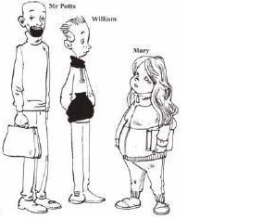
Mr Potts _______________________________________________________
______________________________________________________________________________________________________________________________William_______________________________________________________________________________________________________________________________________________________________________________________Mary_________________________________________________________________________________________________________________________________________________________________________________________

10. Look at this family tree and write the family relationship.
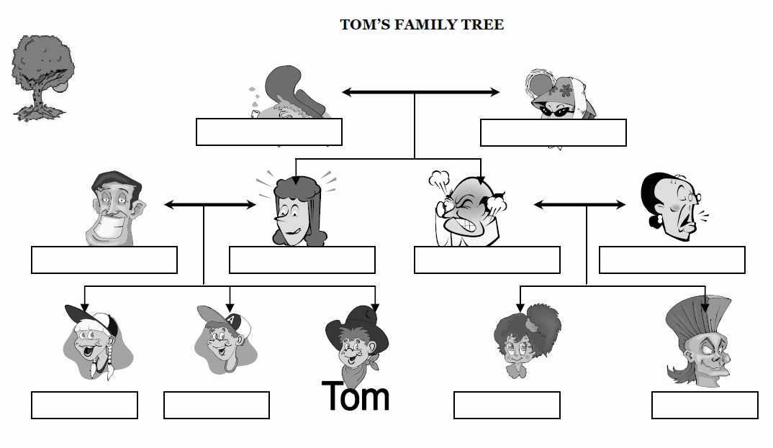

⚠ Help mother, father, sister, brother, grandmother, grandfather, uncle, aunt, cousin

