I like helping
People.




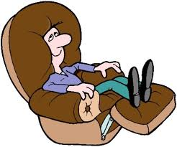





Complete the sentences with the words in the box.
4 + 7 = 10,
I think
I like relaxing all day. I hate working.
I always get the best grades at school.
I think only about myself and I don’t care about others.
Shy boring clever sociable lazy generous helpful selfish stupid modest
I ‘m friendly and enjoy being with other people.
People think I am not interesting at all.

I give all my time and money to people.
I get nervous and embarrassed when talking to people.
1
8
7
6
5
4
3
2
9
10
I don’t like to talk about myself or my achievements to people.
- Peter’s a …………………….. person.
- Bob’s a ………………………. person.
- Mark’s a ……………………..
Person.
4 John’s a ………………………
Person.
- Mary’s a ……………………… person.
- Laura’s a ……………………… person.
- Kate’s a ………………………. person.
- Jane’s a ……………………… person.
- Betty’s a …………………….. Person.
- Mike’s a …………………….. Person.

