Great days in Poe ! ( Bourail )

Wednesday at 7 am, we got up and we went to took our breakfast.
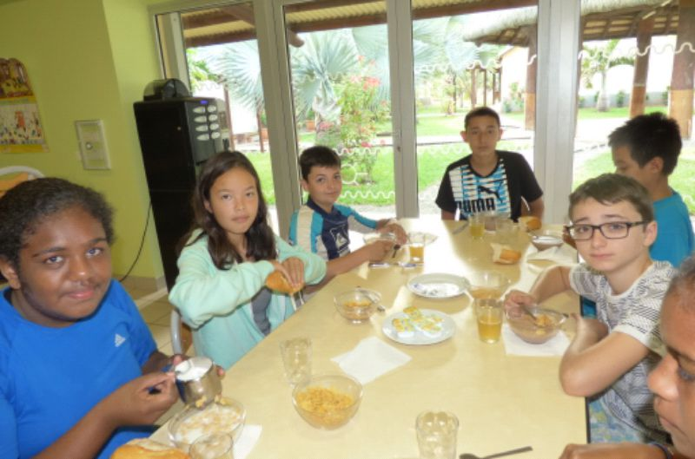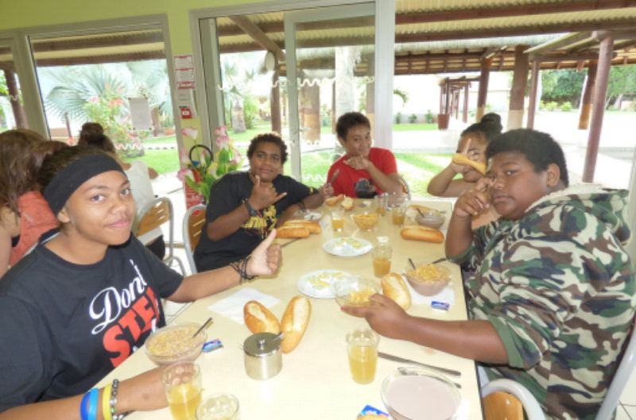

From 7:30 am to 8 am , we had our free time then we were divided into two groups : we had
Water sports ( Kayak and paddle board )
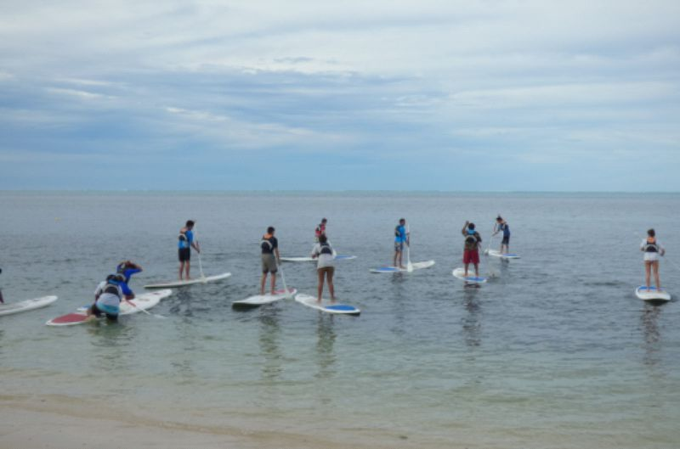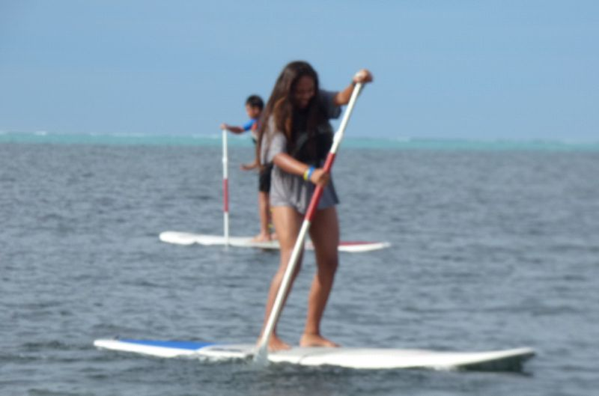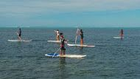
and golf,
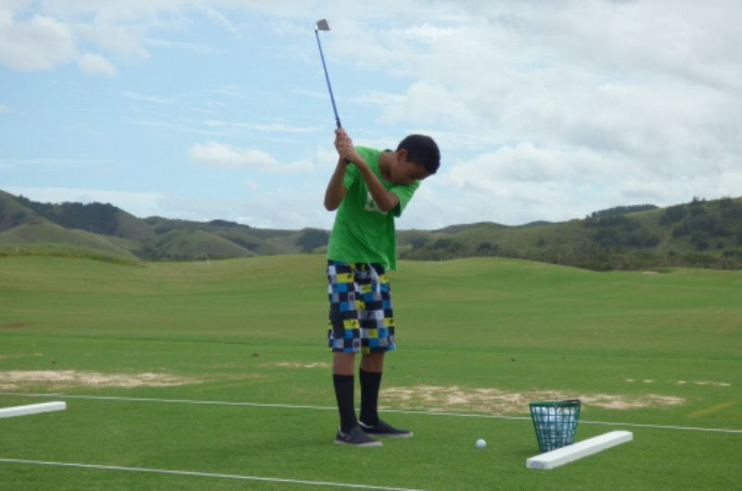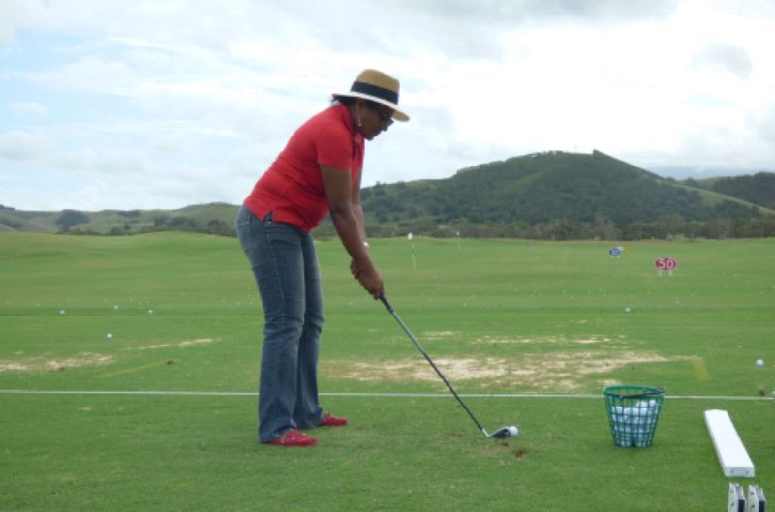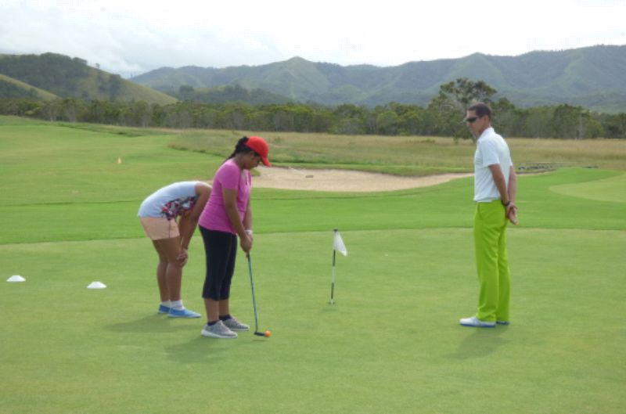
The water activities ended at 11am while the golf group finished at noon.
We took our lunch, at 2 pm, we rode our bikes to the house of Deva
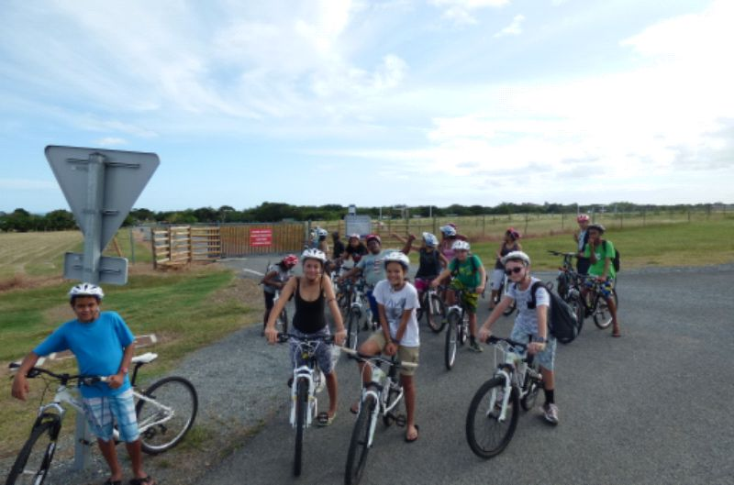
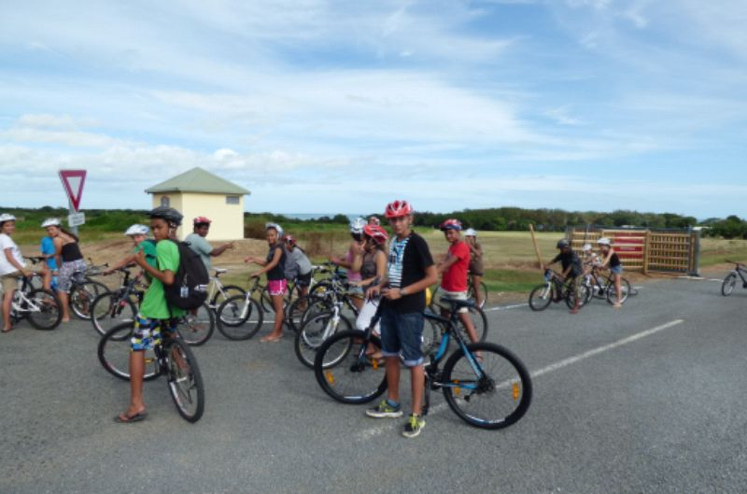
and we visited all the places around.
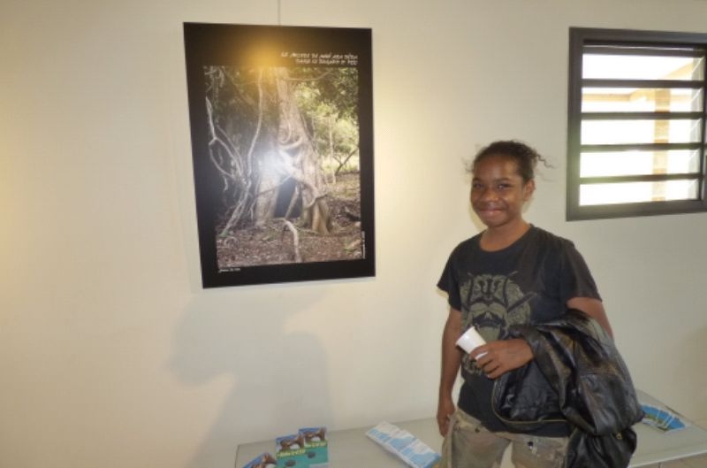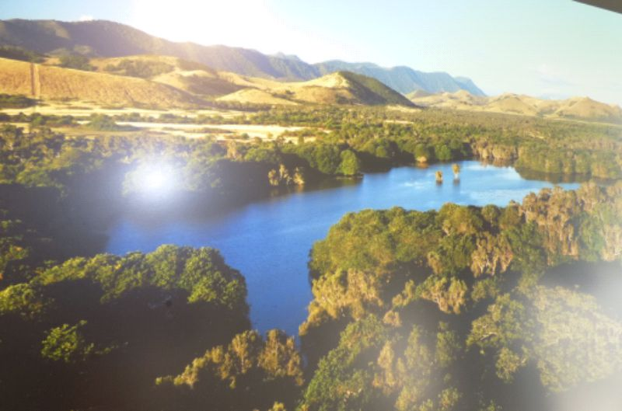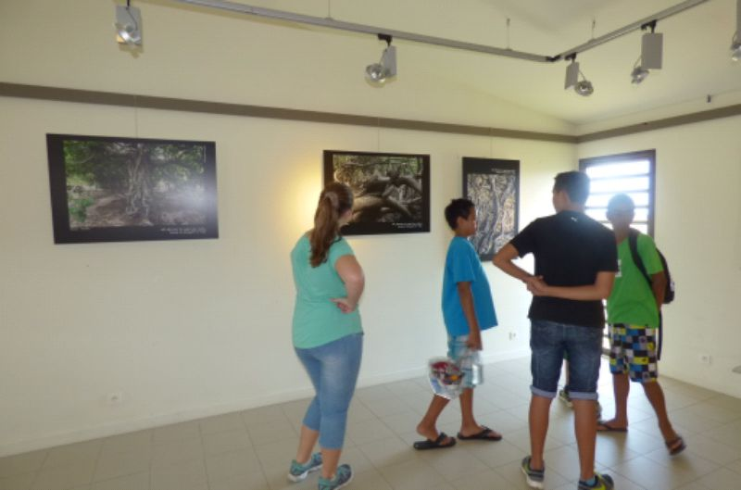
At the end of our visit at 4 pm, we rode back to the CAP. At 7 pm, we had dinner and from 8pm
to 10pm we had free time finally we had to go to bed at 10 pm.

