
New Zealand Week
From Monday 2nd of
June to Friday 6th.

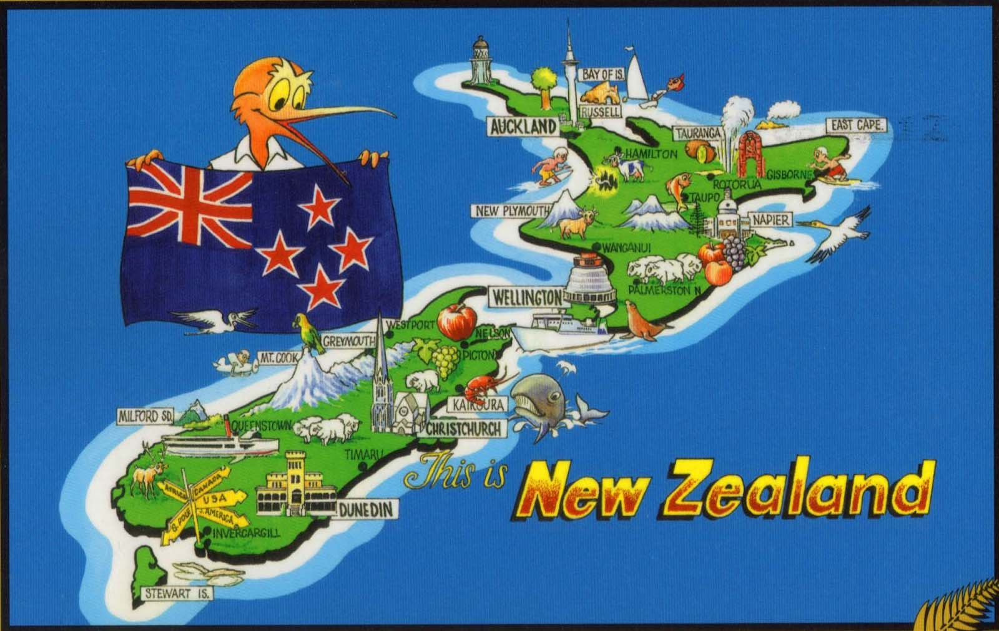
Movie Nights
on Tuesday the ^{3rd} and
Thursday the 5th
Tuesday : 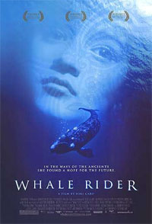 Whale Rider
Session starts at 7:00 sharp!!!
Be there 5 minutes before.

Thursday : 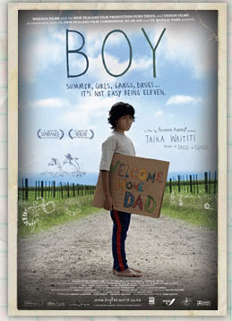 Boy
Session starts at 7:00
Be there 5 minutes before.
CONTESTS
- Quiz
Complete the quiz on this table and put it in the box before THURSDAY 10:OO!!
If there’s a tie, we pick a name at random
Don’t forget to put your name and form class !!

- Writing : write a poem entitled “Aotearoa” 
Give it to your English teacher or Mickaela’s box box before THURSDAY 10:00!!
Rules :
N°1 : Your poem has to be about NZ.
N°2: Your poem has to be printed on a A4 paper.
N°3: Don’t forget to add your name and form class.
N°4: No swear words or inappropriate language.

Don’t forget to put your name and form class!!

- Tatoos: 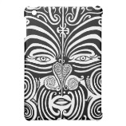
Come at Recess in front of admin and get some brushes and body paint to make a tattoo DURING RECESS.

We take a photo of your tattoo and put up the photos everyday. This happens from Monday to THURSDAY.
Rules :
N°1 : You must respect the Maori tradition and symbols
N°2: Your tattoo must be done during recess
N°3. It can be painted on your body or somebody’s else
N°4: No inappropriate tatoos.

For further information, ask Michaela or one of your English teachers. 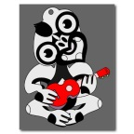

Prizes: for each contest!

First:
a 3000-franc voucher at Mélomania

Second:
a 2000-franc voucher at Mélomania

Third:
a 1000-franc phone card

