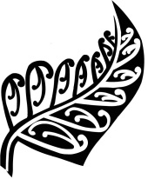ANTOINE KELA’S 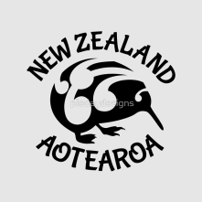 WEEK ! 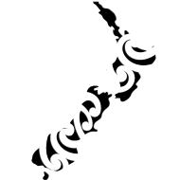

This week's events are:

- Fun Photo shooting : Get your Shepard and Sheep portrait!

- Morning break and afternoon break activities:

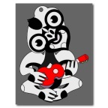 Music from New Zealand 
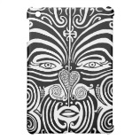Maori Tattooing Contest

- Wednesday afternoon Tī Rākau Stick Games Workshop : 

Rehearsal from 1:00 pm to 3:00 pm with Michaela and the English teachers! Boys and girls are welcome to join us!
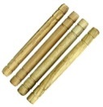 These games consist of the rhythmic throwing and catching of sticks from person to person. (They served as a way of training young warriors to catch enemies' spears in battle.
The show will take place Friday at morning break!
-
Many things to See and Discover!
 Presentations on New Zealand and Maori Culture (brought to you by all the
“secondes”
Check out for what the Rugby Players have to tell you in Cartoon Speech Bubbles !
(Brought to you by Michaela and some of the students)
True or False information about New Zealand. (Brought to you by the “Terminales”)
- Three Contests : Check them out! (Results on Friday!)

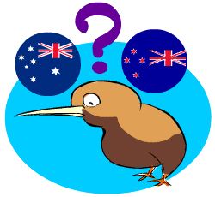 Answer the NZ quiz. (Brought to you by Michaela)
 Write a poem starting with “Aotearoa”!

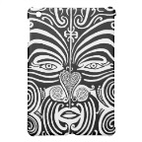 Maori Tattooing Contest

-Movie Nights : 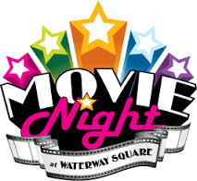!
 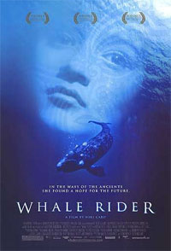 Tuesday night !
Whale Rider is a 2002 drama film directed by Niki Caro, based on the novel of the same
name by Witi Ihimaera.
A contemporary story of love, rejection and triumph as a young Maori girl fights to fulfill a
destiny her grandfather refuses to recognize.

 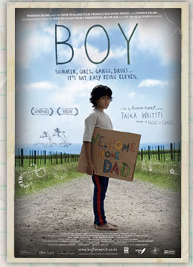 Thursday night !
Boy is a comedy / drama directed by Taika WAITITI in 2010.
Set on the east coast of New Zealand in the year 1984, Boy, an 11-year-old kid and devout
Michael Jackson fan gets a chance to know his father, who has returned to find a bag of
money he buried years ago.

- Lunch : 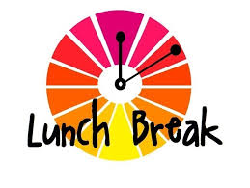
A typical NZ lunch will be prepared at the canteen on Wednesday!
Discover the classic Kiwi Breakfast on Friday morning!

ENJOY!

