American Week

From Monday 3rd of

June to Friday 7th.

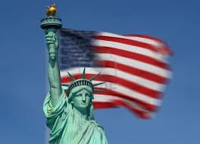
Movie Nights

on Tuesday the 4th and

Thursday the 6th

Tuesday :

The dark knight rises

Session starts at 6:45 sharp!!!
Be there 5 minutes before.

Thursday :

Frankenweenie

Session starts at 7:00
Be there 5 minutes before.
CONTESTS
- Quiz
Complete the quiz on this table and put it in the box before THURSDAY 11:OO!!

If there’s a tie, we pick a name at random

Don’t forget to put your name and class on the quiz!!

- Writing : write a poem entitled “yes, we can”

Put in Mrs Bernut’s box box before THURSDAY 11:OO!!

Rules :
N°1 : The number of lines is limited to 12.
N°2: Your poem has to be about the USA.
N°3: Your poem has to be printed on a A4 paper.
N°4: Don’t forget to add your name and form class.
N°5: No swear words or inappropriate language.

- Drawing Contest:

Put in Mrs Bernut’s box box before THURSDAY 11:OO!!

Rules :
N°1 : Your drawing has to be made on a A4 paper.
N°2: It has to be about the USA.
N°3. Don’t forget to add your name and form class.
N°4: No inappropriate drawings.
N°5: It has to be in colour.
N°6: You can also make a collage.

For further information, ask one of your English teachers.

Prizes: for each contest!

First:
Second:
Third:

For further information, ask one of your English teachers.

