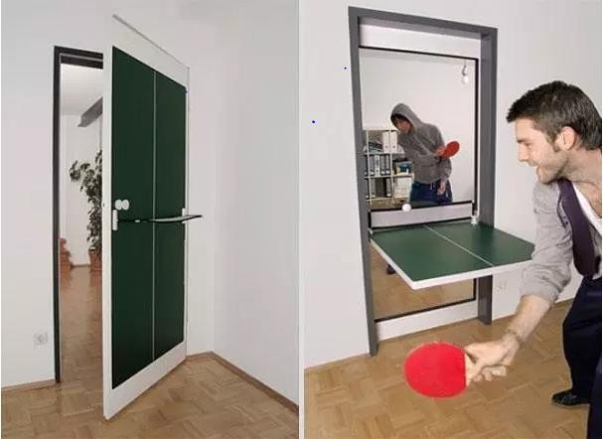

Name of your invention : Definition : it’s revolutionary /amazing /incredible because It will be useful/ fun because You’ll be able to You won’t any longer   
  
***HELP BOX :*** *Here is / let’s …. with / what about...ing ?*

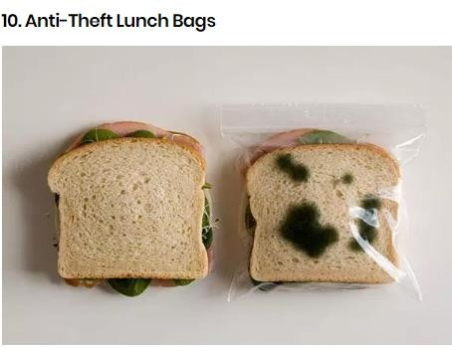

**Flying car :**

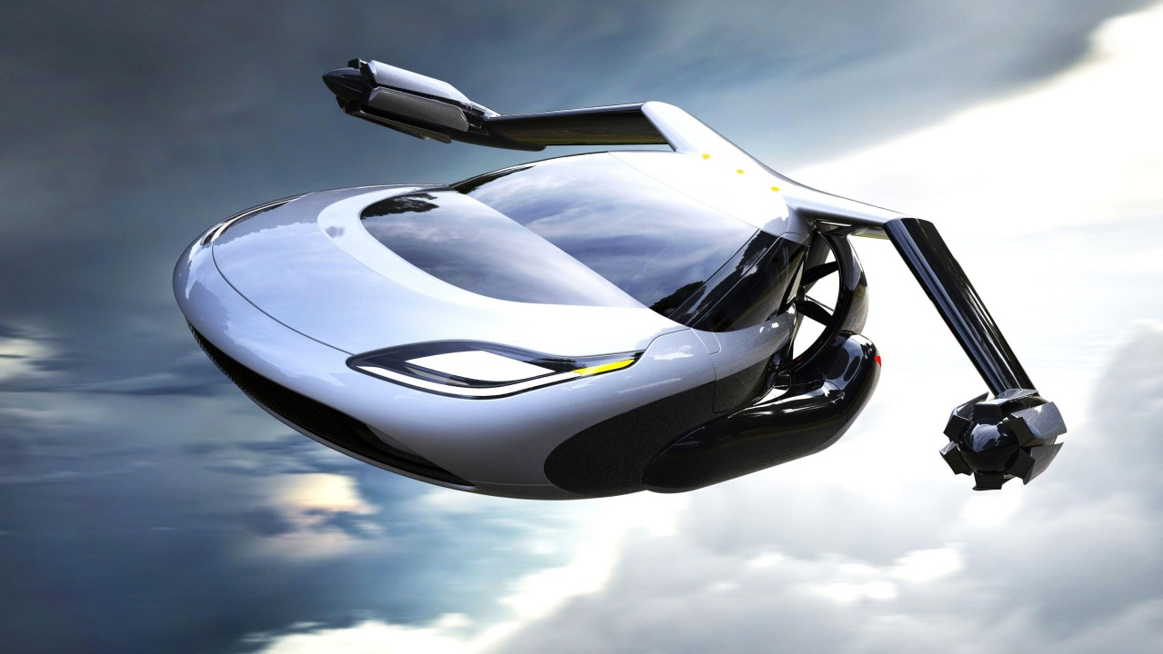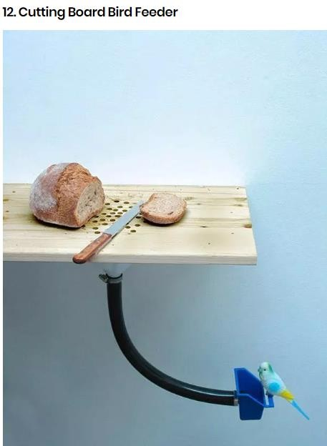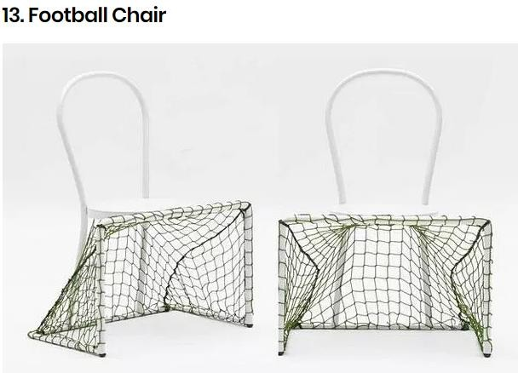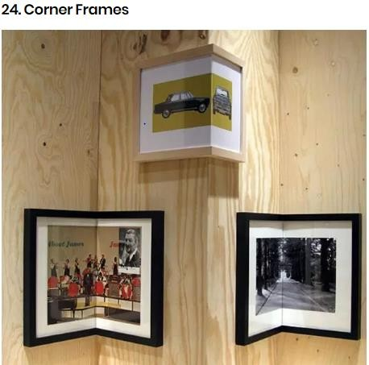

**Gardener robot**

